BOXING DAY

TYN Y GROES HILL RACE

RHEDEG MYNYDD FELL RUN
Saturday/Dydd Sadwrn, Dec/Rhagfyr 26^{th/ed} 2009
Start/Cychwyn 12.00 noon Tyn-y-Groes, Ganllwyd, Gwynedd
Bydd y Tyn y Groes yn agor am 11.00
The Tyn y Groes is open from 11.00am

2.5 miles/milltir, esgyn 700 feet ascent
Yn Gyntaf rhedeg cyn 1925/First run before 1925
Revived in summer 2005 Dim Gwobrau/ No Prizes
Festive run around the Tyn y Groes Hill Race Course, Timed.
Rhedeg sosial o gwmpas cwrs Rhiw Tyn y Groes
Entry/Tal: Free/Di Dal
www.brodysynniac.com www.wfra.org.uk www.tynygroes.com

Bob Chilton onygena@onetel.com 01341440611
The original race went in an almost straight line from the Tyn-y-Groes Hotel crossing
a bridge (no longer existing) and straight up a steep slope to the summit of Mynydd Penrhos and back again. Tree planting and safety considerations do not permit the use of the old route but the new route preserves the essence of the old .
The Boxing day race starts from the bus stop outside the Tyn-Groes Hotel goes down to the picnic site and climbs very steeply, levels out for an undulating winding stretch with a slight gain in height to the summit, then declines slowly at first then more steeply before crossing a minor road and finally following the riverbank upstream through the picnic site and up the path to the finish at the bus stop outside the hotel.
The route will be marked or taped and marshalled at key points.
Running shoes (preferably fell shoes) are recommended. The terrain is slippy and rugged in parts. First aid cover in Tyn-y-Groes.
We request that you bring your fell kit just in case the weather is severe enough to make it necessary. Walkers welcome and start immediately after runners.

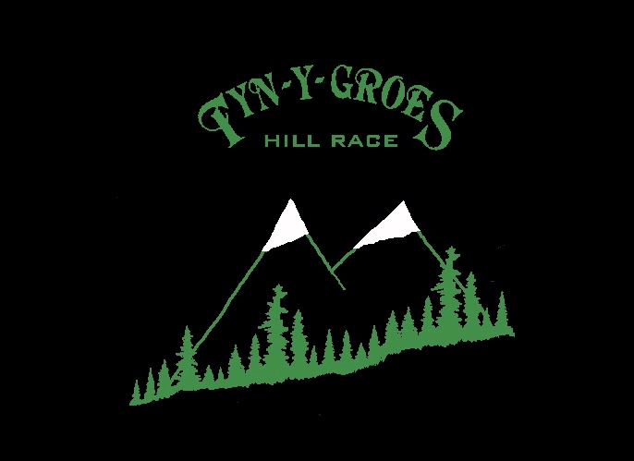
Trefnwr/Organiser Bob Chilton, Hendre Berfedd, Hermon, Dolgellau, Gwynedd LL40 2LW

